**PANCHANGA-Article-4: 26.09.2022**

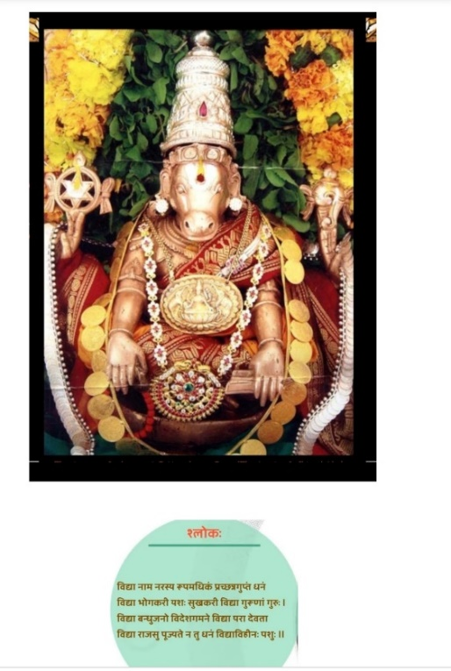

ज्ञानानन्द मयं देवं निर्मलस्फटिकाकृतिम् ।

आधारं सर्व विद्यानां हयग्रीवम् उपास्महे।। Hayagriva Stotra- Swami Desikan

With Acharyas’ Krupa and Lord Lakshmi Narasimhan’s Anugraham and Lord Lakshmi Hayvadana Perumal’s Krtm, this article about Panchanga is written by me (K.V. Krishnan) with the blessings of my Guru Sri. Dr. N.V.R.A Raja (**Astrology Jyotisha Kesari and Astana Vidhwan-Ahobila Mutt)** and his father **Poojya Sri. N.V. Raghava Chary Garu**, the Meena-2 Siddhantha Stapakar.

Our main aim in this article is, to introduce the concepts of Panchanga which is a part of Sanatana Dharma and Calendar in this Land for millions of years. Even before invaders’ times Panchanga was practiced by all of us in our day to day works.

**Let us continue with review the of Nakshatra in this article.** Panca-Angas are essential to individuals as they help one to understand “**the** **quality of time”** (i.e., time one can choose to execute any **Karma** as dictated by Shastra). We will **understand** as we proceed further that Numbers 3,5,7,9, etc wherever they come in Vedic Grantas, like Jyotisha are related to specific Tatva as per Sanatana Dharma and are not random.

For example,

The Number (3) is connected to three Gunas**, namely Satva, Rajas and Tamas.**

The Number (5) is connected to five Butas**, Akasa, Vayu, Agini, Jalam and Prutvi**.

Astrologers know the importance of these two numbers 3 and 5, as it is discussed in detail in “The study of Astrology”.

As **our Guruji Sri. Dr. N.V.R.A Raja** keeps stressing in every one of his lectures **three Gunas (Satva, Rajas, and Tamas)** are going to be **the** primary factor based on which the Nakshatra Siddhanta Astrology, will develop further in future, though presently also Guruji has used it extensively in timing of events.

27 Nakshatras and their deity is divided into 3 groups of 9 Nakshatra each. For easily remembering them there is a particular way it is written and the same is shown below:

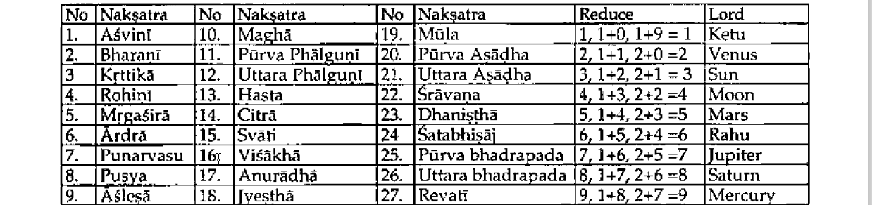

The moon takes 27- 1/3days (approximately) to circle the zodiac. It is the time taken to conjoin a fixed star in the sky. This figure of 27 1/3days is rounded off to 27 Nakshatras. The extent of each Nakshatras is 13° 20' (360°/ 27 = 13° 20'). The shortfall of about 1/3 day (27 1/3 -27 = 1/3) is used to define a 28th Nakshatra called Abhijit Nakshatra. The span of Abhijit is slightly more than one pada. Names of the Nakshatra (**28 schemes**) and their, numbers are given below.

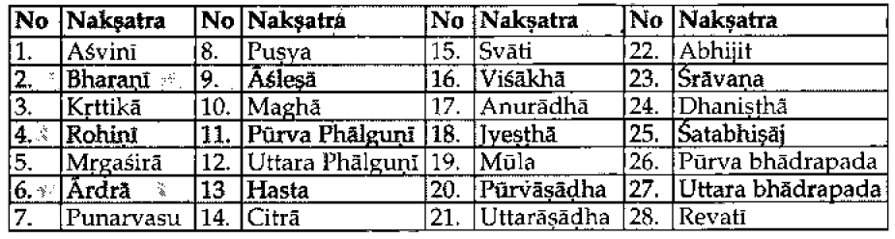

Abhijit is an intercalary Nakshatra meaning that it does not exist in the physical space but does exist in the spirit space by overlapping some portions of two other Nakshatra, like a bridge between them. Total span of Abhijit Nakshatra is 19 Ghatika. This includes the last pada 3°20' of Utrashada Nakshatra which is 15 Ghatika (one Nakshatra = 60 Ghatika 13°20') technically, although in reality it is slightly different)

Every Nakshatra has 4 (four) pada or feet. Twenty-seven Nakshatras have 108 pada (27 x 4 = 108). Each pada measures 3°20' arc (13° 20'/4 = 3°20')- The Nakshatra mandala defined from Aswini as the starting point refers to the physically manifested outer covering of the universe around the earth.

A Rasi is created by nine Nakshatra pada reckoned continuously. The first Rasi (zodiac sign) is called Mesa (Aries) and has Asvini (4 pada), Bharani (4 pada) and Kritika (1 Pada). In this manner three Nakhsatra's contribute nine pada to define the Rasi. Twelve Rasis are created with 108 Nakshatra pada (108 /9 = 1 Rasi = 9 x 3° 20' = 30°).

The four pada of every nakshatra are (1) Dharma (2) Artha, (3) Kama and (4) Moksha. The predominant nature of a Rasi is known from the predominance of a particular **Ayana (goal) - Dharma Artha, Kama or Moksha.**

**Consider Mesa (Aries):** It has 4 pada of Aswini = 1 each of Dharma, Artha, Kama and Moksha; then 4 pada of Bharani being 1 each of the four types and then the 1st pada of Kritika which is Dharma. Thus, Mesa has 2 each of Artha, Kama and Moksha pada and 3 Dharma pada - Dharma dominates and defines the Ayana of Mesa. In this manner we determine the Rasi Ayana which is the predominant direction indicated by the sign. While all the four Ayana are present, one will have a slight dominance over the other three. **It is noteworthy that the Nakshatra have a fine balance of all four directions of life while the Rasi they form has an imbalance resulting in one of the Ayana dominating**. This is true as far as the physical manifestation (27 Nakshatra are concerned). The 28 Nakshatra scheme does have a dominant Ayana for each of the Nakshatra, although they have tattva.

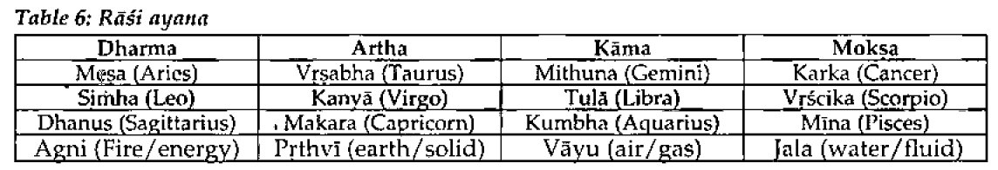

**Replace words:** By simply replacing the word 'Dharma' with Agni (Fire/energy); 'Artha' with Prthvi (earth/solid); 'Kama' with Vayu (air/gas) and 'Moksha' with Jala (water/fluid).

Dharma Ayana

Artha Ayana,

Kama Ayana,

Moksha Ayana

The predominant nature of the signs manifests as

**Fire/Energy:** Aries, Leo, Sagittarius

**Earth/Solid:** Taurus, Virgo, Capricorn. Air/Gas:

Gemini, Libra, Aquarius.

***Water/Fluid:***Cancer, Scorpio, Pisces.

Dharma: Duty and its quality is measured.

Wealth: and its quality are measured through righteousness.

Artha: Wealth and its quality is seen from the power it wields.

Kama: Desire and its quality is defined from refinement.

Moksha: Emancipation and its quality (path) is defined by spirituality or religion.